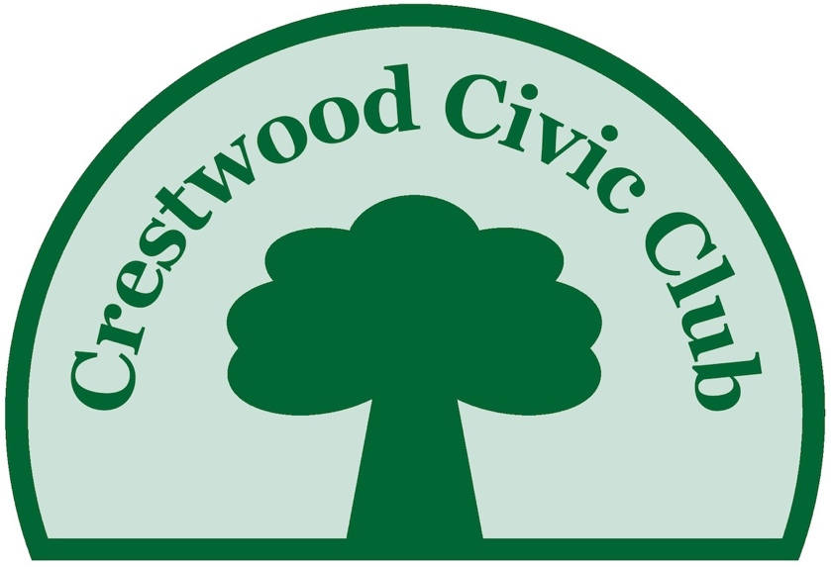

Fall, 2021 202020,2020202020202022019

A publication of the Crestwood Civic Club
Dear Neighbors,

During this difficult time of COVID, with in-person gatherings not advised, your Civic Club and Architecture Committees have continued to meet virtually to carry on the business of our community. If you have questions or concerns, please feel free to email me at president@crestwoodglencove.org or call or text to 832-597-1359. Please add this email address to your contacts! A lot of our communications are done via email, and by adding this email address, those communications are less likely to end up in your SPAM folder. We are also experimenting with text messages. Don’t worry, we don’t intend to send very many, but having this ability will be handy in emergency situations and for last minute reminders of meetings and gatherings.

Many of the complaints I get require the involvement of the City of Houston. Things don’t happen quickly there, and often the answer is that funds are not available. That doesn’t mean we stop trying but this can be frustrating. We do find that complaints registered with 3-1-1 help, especially if there are multiple complaints about the same issue. Please let me know if you file a 3-1-1 as I will forward that to Councilmember Kamin’s office and her staff will track the progress and, in some cases, facilitate a quicker solution.

Tami Hamilton
President

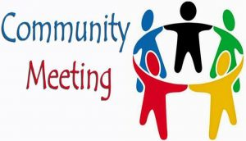
ro

October 19, 2021 at 6:30 PM
Via Zoom

Community meeting
School update
Garden day
Mike’s RPP
Speedbumps

Ways to Stay Connected

Website: crestwoodglencove.org
Here you can find important information about deed restrictions, membership, trash schedules, committees, and more.

Facebook: Crestwood/Glencove
This is a private page for residents only. We have about 90 members now, so the coverage has improved. This is a good place to check on events, report lost dogs, coral snakes, or ask advice of your neighbors. It was a handy place to check recently when we had the extended power outage on some of our streets.
- Download the Zoom App or simply click on the meeting invitation. If you need an invitation, email president@crestwoodglencove.org or text me at 832-597-1359.
- We plan to have several speakers, including Mr. Jose Cordova, new principal at Memorial Elementary, Rep. Ann Johnson, and Councilmember Abbie Kamin. Please send questions in advance or come prepared to ask questions at the meeting.
- Like to propose an agenda item? Please contact me prior to the meeting.
NOVEMBER 6
12 PM – 3 PM

CLICK HERE FOR MORE Fall Festival Details

Offensive Language in our Deed Restrictions

Last year, we reported that most of our deed restrictions contain racially-biased language limiting residents to Caucasians only. These clauses are common for deed restrictions created in the 1930s and 1940s. Of course, the clauses are not legal per the Civil Rights Act of 1965, but the language is still there. Amending the deed restrictions will not remove it, but only amend that clause. CNN did a story on this issue in February of last year (https://www.cnn.com/2020/02/15/us/racist-deeds-covenants/index.html).

Your Civic Club worked with Sen. John Whitmire to get a law passed in the Texas Legislature that would allow for an easy way to get these clauses removed from our deed restrictions. Without a new law, we could only amend the deed restrictions and that required legal expenses and 75% notarized participation from the community. We are happy to report that the new law passed and was effective on September 1, 2021!

The Texas District Attorney’s office is now working out the operational details of getting the changes made. We plan to participate as soon as it is possible. The Civic Club board is very excited to be able to make our deed restrictions reflect the wonderful diversity we have in our community.

Your Civic Club has partnered with Trees for Houston to add 40 trees to the esplanades on Westcott. Most of these trees will be planted on the esplanade closest to Glenwood and Westcott, where the median is almost bare. The City of Houston has specific rules regarding the type of tree, distances from curbs, interfering with sight lines, and other regulations. The City has approved the tree plan. A corporation has donated the funds and volunteers to make this happen, so we get more trees for free! The plan is for the trees to be planted on October 14. As a result of our efforts, Memorial Elementary will also have additional trees planted on the campus.

Sometimes, we hear complaints about businesses being run from homes and causing issues with parking and traffic. Running a business from your home is prohibited in our deed restrictions. However, things have changed with technology and now especially with Covid. The last time the City got involved in one of these cases in our neighborhood, one of the attorneys provided some clarifications. It’s fine to work from home, as many of us are doing. What isn’t fine is to have employees working from your home on a regular basis or having a lot of customer traffic. Please be mindful of your neighbors in this regard. Likewise, renting your home on a temporary basis like AirBnB or VRBO is prohibited.

In the past, we have distributed printed directories. Would you prefer to have an electronic copy? If you have a preference, please send us a note. We will likely offer this option next year on our membership forms. It will save the club money and for some of us make the directory easier to find when you need it.

The annual Block Party has been postponed until the spring, when hopefully it is safer for us all to get together. Stay tuned for a date in April.

DEED RESTRICTIONS

We are lucky to have dedicated volunteers in our Architecture Committees who have worked for years to preserve the character of our neighborhood. Thank you to Gail Baxter, Priscilla McCleroy, Mary Holmes, and Lenni Burke on the Crestwood committee, and Alan Svoboda, Mike VanDusen and George Li serving Glen Cove.
CRESTWOOD SECURITY FUND ASSOCIATION

Unlike many other neighborhoods, the security program is managed separately from the Civic Club. You can reach the security team at security@crestwoodsecurity.org and on the website at crestwoodsecurity.org. Crime rates have increased all over the US, and Houston is no exception.
Participation in the program has many benefits: e.g., 1) on-property checks, 2) security officer assistance, such as responses to security concerns at your home, being escorted to your door when concerned about returning home alone, 3) officer response to security alarms (within minutes), 3) vacation watch monitoring of your home, and 4) monitoring your home for packages, newspapers, etc. that may build up, making the home appear un-occupied, while you are away. Conversely, for non-participants, the security officers are legally prohibited from accessing their property and therefore from responding to any issues or requests from non-participants.
Only about 50% of residents support the program. If we all chipped in, we could decrease what participants pay significantly!

There are at least 7 subdivisions in our Crestwood Civic Club. Marilane and Rains Way have their own HOA rules. If you live in Glen Cove 1, 2 or 3, your house plans for construction or renovation are reviewed by the Glen Cove Architecture Committee. Contact them at architecture@crestwoodglencove.org. If you live in the Crestwood subdivision, please contact crestwoodarchcom@crestwoodglencove.org. If you aren’t sure which subdivision you are in, please see this map. Deed restrictions are on the website here. Crestwood Acres does not have an active architecture committee. We reached out earlier this year for volunteers but found none. If anyone living in Crestwood Acres would like to reform a committee, please contact the Civic Club. We are happy to help.

Our neighborhood is always in transition with new home construction on most streets. Enforcing our deed restrictions is an ongoing and important process. Like to help? Let us know.

WE
NEED
YOU!!!
Would you like to be more involved in your community? Get to know some neighbors? Contribute to positive change? You would be very welcome. We have varied opportunities to match your time, skills, and interests. Just send a note to president@crestwoodglencove.org.

- We have one open Board Position. We meet 10 times per year (now via Zoom) for about 1.5 hours. Help make decisions and deal with the bigger issues.
- We have open Block Ambassador positions.
- A new committee is being formed to work on alternatives for Blossom to make the street safer for drivers, pedestrians, and cyclists. Since Eastern Glades opened, the traffic has increased. It could be better!
- Participate with City of Houston to work on alternatives for a safer crossing of Westcott at Blossom. We have state representatives and city officials engaged.
- Help with new social activities we want to start soon…Mahjong, book club, dinner clubs, play dates, other suggestions…
- Help with technology such as texting and website updates
- Update our Facebook page
- Help with the newsletter
- Plan our Block Party

Board Members: Tami Hamilton, President
Tom Tynan, Vice President
Kathy Bernobich, Treasurer
Mike VanDusen, Secretary
Liliya Bayer
Hande Castigleone
Matt Elbert
Wally James

